|  |  |
| --- | --- |
|  | https://bu.ac.bd/webform/user_images/861980.png |



BU

Computer Fundamentals and Office Application

Batch-28

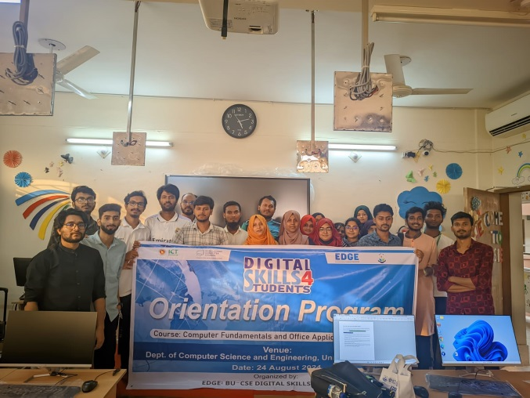

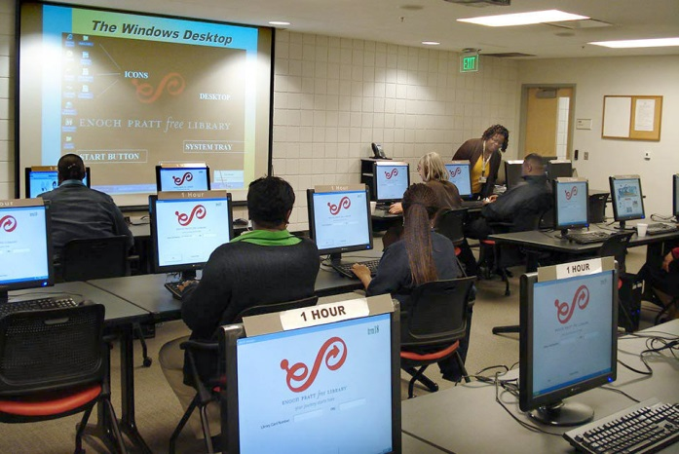

Dr. Tania Islam  
Assistant Professor  
Cell :01059505136  
Email :tania.bd.09@gmail.com

Development

Learning

Due to the courses, I think I can able to solve various problems of Ms Word, Ms Excel and Microsoft PowerPoint .

Experience

* Ms Word
* Ms Excel
* Ms PowerPoint
* Typing

Tania mam trains us very easily in every section of this course. I am enjoying all the classes. Surely this helps me in my upcoming computer related tasks.

|  |
| --- |
|  |